Integration Factory - Framework
Technical Document on Windchill BOM Data - SAP Integration Using ESB

Customer: | Tata Technologies (Internal POC)
Location: | Pune
Project Name: | Integration Factory - Framework

TATA TECHNOLOGIES -PROPRIETARY AND CONFIDENTIAL
This document and any information contained therein is of a confidential nature and for the customer's use only. Customer agrees neither to use it, except for the purpose intended, nor to disclose it, in whole or in part, to any third party without the written consent of Tata Technologies Pune Ltd.

All rights reserved. No part of this document may be reproduced, stored in a retrieval system, translated or transmitted in any form or by any means, electronic, mechanical, photocopying, recording, or otherwise, without the prior written permission of Tata Technologies Pune Ltd.

Document History
Document Revision History
Version | Date | Author | Summary of Update
1.0 | 13/04/2021 | Rajat Chaurasia | Initial document creation

Contributors
Names | Organization
 | TATA Technologies Ltd

Reviewed By
Names | Organization
 | Tata Technologies Ltd.

Table of Contents
➢ Introduction: 4
➢ Overview: 4
➢ API Based Integration: 4
➢ ESB Workflow Details: 4

Introduction:

Purpose:
This document is a technical document to achieve integration between Windchill BOM Data (PLM Tool) and SAP (ERP Tool) using middleware ESB WSO2. The document will mainly guide the technical support personnel to go through the fundamentals and steps to be followed for troubleshoot on WSO2 workflow. The document also covers the functional objectives behind the customization.

Audience:
Tata Technologies ERP, PLM and ESB Teams

Overview:
The integration between Windchill BOM Data (PLM) and SAP (ERP), has been done through ESB using API based communication.

API Based Integration:

In this approach, Windchill will send BOM data to SAP through ESB. There will be no direct communication between Team Center and SAP.

For this, ESB team has created a REST API which will accept the BOM data from Windchill in JSON format. After ESB received the BOM data, processing of the data will be done in ESB. Processing of the data will consist of Data Transformation, Data Enhancement, Format Conversion and Data mapping. Once data processing is completed, ESB will consume SAP API by fulfilling security constraint and pass the part data to SAP.

API used to send the part data from ESB to SAP is created by SAP Team.

ESB Workflow Details:

The workflow is created in WSO2 Integration Studio by using inbuilt mediators and sequences. Workflow accepts the BOM data from Windchill in JSON format. Once workflow receives the BOM data by using data mapper mediator Windchill attributes are mapped with the SAP attributes. Once mapping completes, we use Header mediator to pass the security details which are essential to consume SAP API. After this we use call mediator to consume SAP and pass the part data and the response received from SAP is sent to Windchill using respond mediator.
In this workflow Iterator and Aggregator mediators are used to accept multiple BOM data from Windchill and send the response accordingly.
Once the workflow is completed and tested. REST API is published by using WSO2 API Manager after which the Windchill will be able to consume the API and send part data to ESB. WSO2 API Manager also help to add CORS policy and security to the published API.
For adding security to the API Basic Authentication mechanism is used which can be changed through WSO2 API Manager.

Below screenshot show the configurations made in WSO2 API Manager to publish the API.
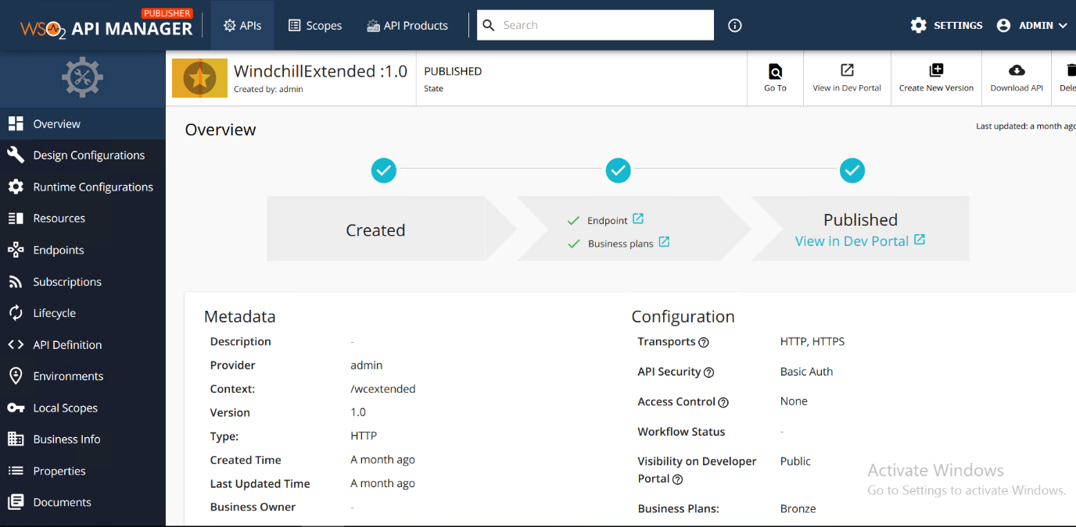

Below screenshot shows the workflow created in WSO2.
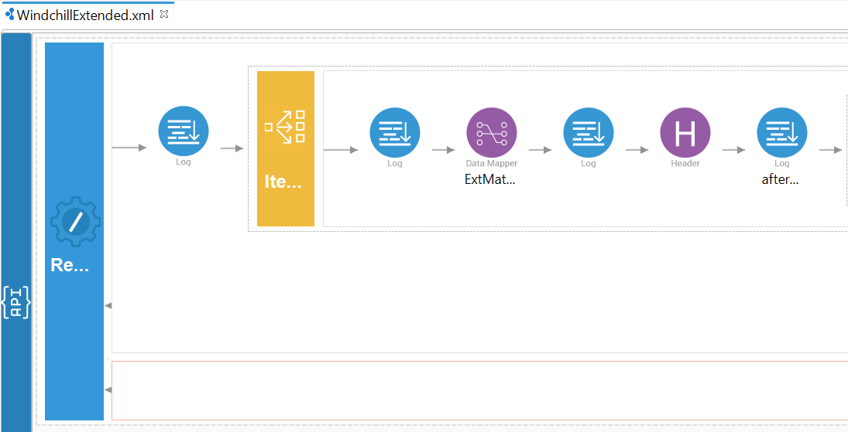
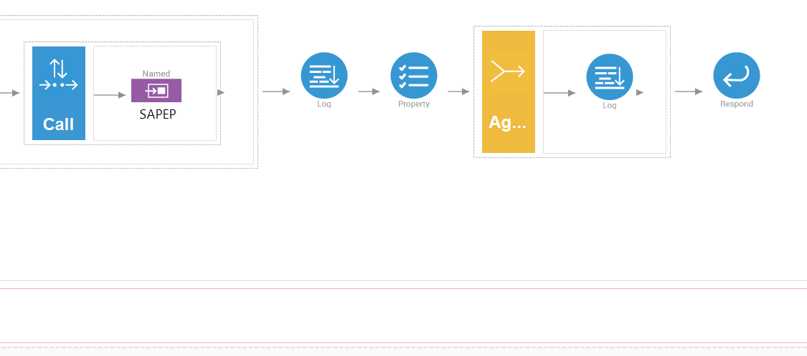

Below screenshot shows the attribute mapping used in the workflow.
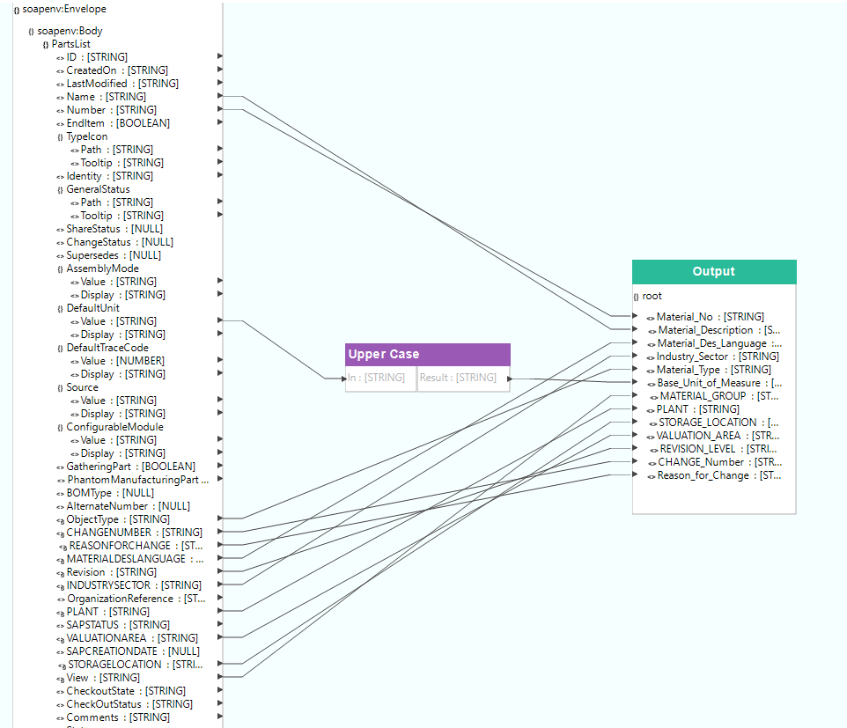

Attribute Mapping between Team Center and SAP.
Windchill BOM Data Attributes | Attribute Modification | SAP Attributes
Name | - | Material_Description
Number | - | Material_No
DefaultUnit: Value | Upper Case | Base_Unit_of_Measure
ObjectType | - | Material_Type
ChangeNumber | - | Change_Number
ReasonForChange | - | Reason_For_Change
MaterialDesLanguage | - | Material_Des_Language
Revision | - | Revision_Level
IndustrySector | - | Industry_Sector
Plant | - | Plant
ValuationArea | - | Valuation_Area
StorageLocation | - | Storage_Location
View | - | Material_Group

Below screenshot from the Postman.
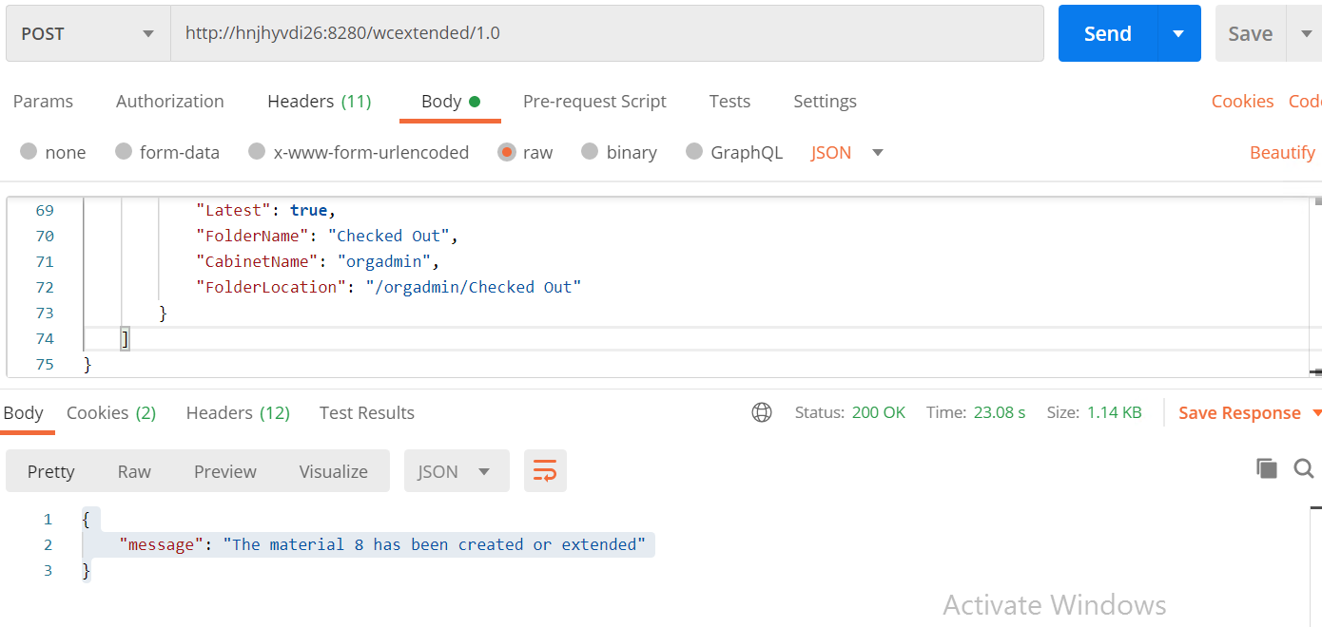

In the below table we can check API URL (End Point), JSON request body and Response Details
ESB End Point URL | http://hnjhyvdi26:8280/wcextended/1.0
Request JSON Format from Windchill | {  "PartsList": [  {  "ID": "OR:wt.part.WTPart:85851",  "CreatedOn": "2020-07-31T06:49:37Z",  "LastModified": "2021-03-12T09:37:16Z",  "Name": "TestWTPart7",  "Number": "0000000008",  "EndItem": false,  "TypeIcon": {  "Path": "http://hnjhyvdi28.tatatechnologies.com/Windchill/wtcore/images/part.gif",  "Tooltip": "Part"  },  "Identity": "Part - 0000000008, TestWTPart7, A.1",  "GeneralStatus": {  "Path": "http://hnjhyvdi28.tatatechnologies.com/Windchill/com/ptc/core/htmlcomp/images/checkedout_byyou9x9.gif",  "Tooltip": "Working copy, checked-out to you"  },  "ShareStatus": null,  "ChangeStatus": null,  "Supersedes": null,  "AssemblyMode": {  "Value": "separable",  "Display": "Separable"  },  "DefaultUnit": {  "Value": "ea",  "Display": "each"  },  "DefaultTraceCode": {  "Value": "0",  "Display": "Untraced"  },  "Source": {  "Value": "buy",  "Display": "Buy"  },  "ConfigurableModule": {  "Value": "standard",  "Display": "No"  },  "GatheringPart": false,  "PhantomManufacturingPart": false,  "BOMType": null,  "AlternateNumber": null,  "ObjectType": "Part",  "CHANGENUMBER": null,  "REASONFORCHANGE": null,  "MATERIALDESLANGUAGE": null,  "Revision": "A",  "INDUSTRYSECTOR": null,  "OrganizationReference": "{\"type\":\"text\"}",  "PLANT": null,  "SAPSTATUS": "not sent",  "VALUATIONAREA": null,  "SAPCREATIONDATE": null,  "STORAGELOCATION": null,  "View": "",  "CheckoutState": "Working copy, checked-out to you",  "CheckOutStatus": "cat-working-copy",  "Comments": "For SAP changes",  "State": {  "Value": "INWORK",  "Display": "In Work"  },  "LifeCycleTemplateName": "Basic",  "VersionID": "VR:wt.part.WTPart:85850",  "Version": "A.1",  "Latest": true,  "FolderName": "Checked Out",  "CabinetName": "orgadmin",  "FolderLocation": "/orgadmin/Checked Out"  }  ]  }
Response JSON Format from SAP | {  "message": "The material 8 has been created or extended"  }

After getting above response from the SAP API it means part data has been successfully inserted/updated in the SAP system.

